Assignment-1
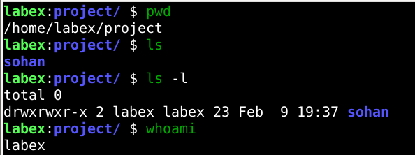

Explain the purpose of pwd, ls, and clear.?
What information does the history command provide?
The pwd command is used to display the current working directory, helping users know their exact location in the Linux file system. The ls command lists all files and directories present in the current directory, making it easier to view contents, while options like -l and -a provide detailed and hidden file information. The clear command is used to clear the terminal screen, improving readability by removing previous outputs. Additionally, the history command displays a list of previously executed commands along with their command numbers, which is useful for reviewing, reusing, and managing past terminal activities.

Assignment-2
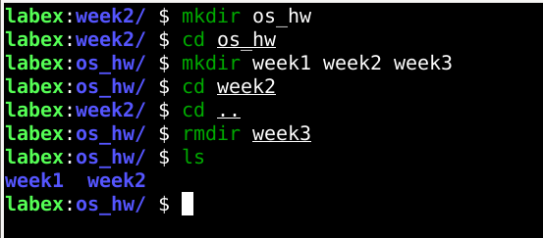

Assignment-3
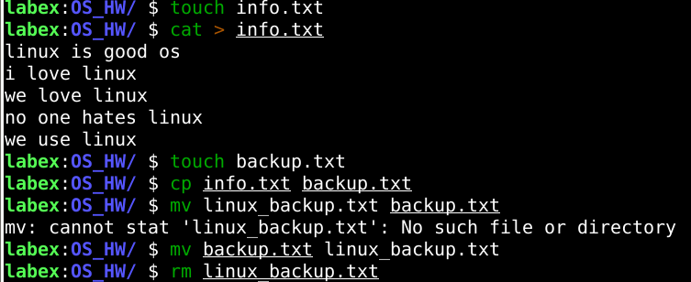

Assignment-4
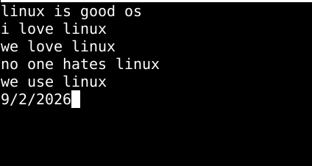
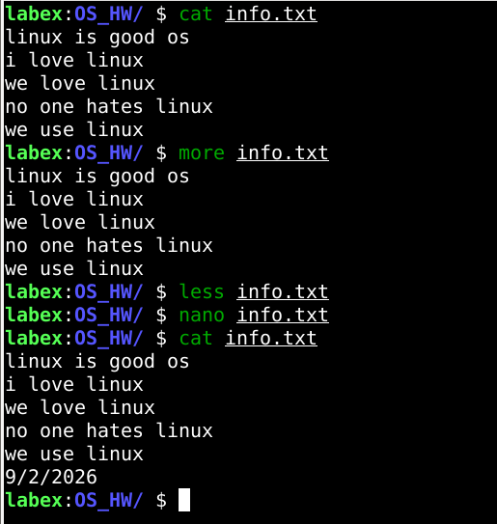

What is the difference between nano and vi?
nano is a simple and beginner-friendly text editor in Linux that allows users to directly type, edit, and save files using straightforward keyboard shortcuts like Ctrl + O to save and Ctrl + X to exit. In contrast, vi is a more powerful and complex editor that uses multiple modes—Command mode, Insert mode, and Last line mode—offering advanced features such as search, replace, macros, and precise navigation. While nano is suitable for quick edits and beginners, vi is preferred by programmers and system administrators for tasks that require more control and efficiency.

